Report and Photographs with caption and dates of Student Induction/ Orientation Programme for last five years (2016-2021)
Report of the Orientation Programme
Every Year A.S. College of Education organises an orientation programme for the newly admitted B.Ed. students. Purpose of the orientation Programme is to help new students adjust and feel comfortable in the new environment, inculcate in them the ethos and culture of the institution, help them build bonds with other students and faculty members, and expose them to a sense of larger purpose and self- exploration.
Initial orientation by the Principal: - As part of the admission procedure the principal conducted an orientation interview where a general overview of the course, the possibilities and challenges are shared with the parents as well as the students to inculcate motivation and mental readiness to the course.
Orientation by the Teachers: -Teachers who are the members of the admission committee assesses the student’s preparedness for the programme. After verifying the certificates, they interact with the students and probe attitude and interest of the aspirant to the teaching profession.
The main objectives of the orientation programmes are:
- To make the pupil teachers aware of the academic aspects of the course.
- To aware them about the environment of the institution.
- To create an atmosphere for pupil teachers to get to know other students and faculty members.
- To generate the understanding that E-learning is the wheel for new innovations.
- To aware about the rules and regulations of the institution,
- To familiarise the pupil teachers with the history and upcoming co-curricular and extracurricular activities of the institution like workshops, exhibition, seminars, conferences etc.
- To create an online environment at this pandemic time.

Report of the Orientation/ Induction Programme (2016-17)
10/8/2016-11/8/2016

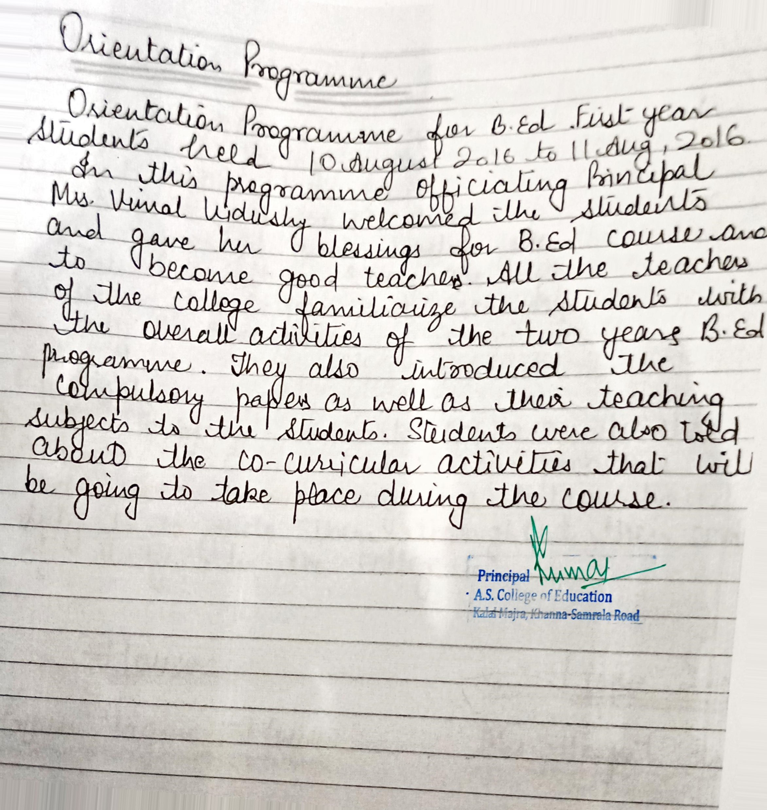
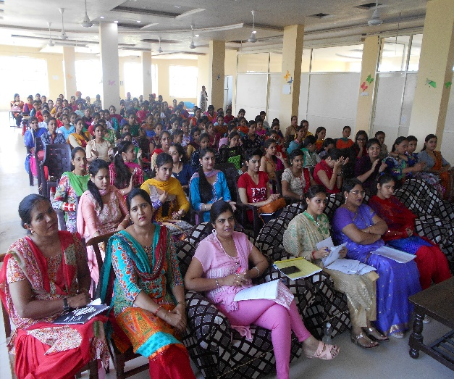

Report of workshop on School Internship Programme(2016-17)
23/7/2016-26/7/2016, 13/10/2016 and 09/03/2017- 10/3/2017, 14/3/17-15/3/2017
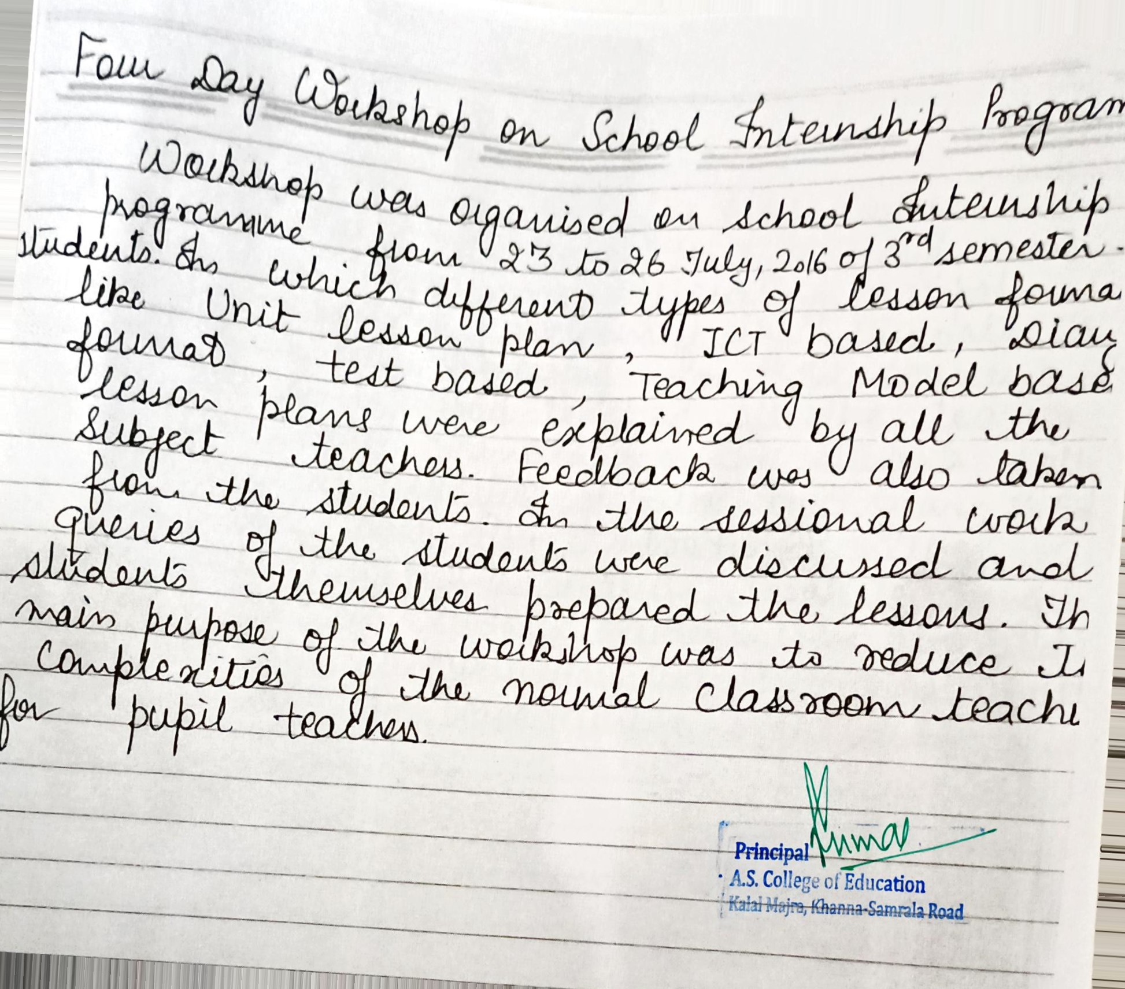
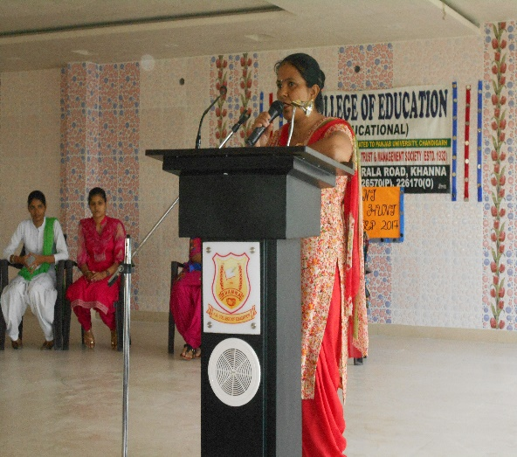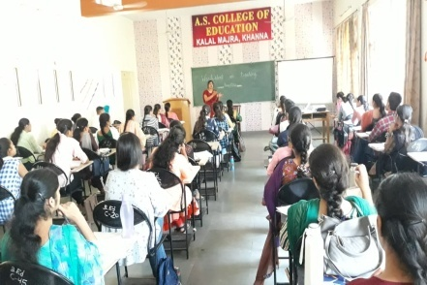
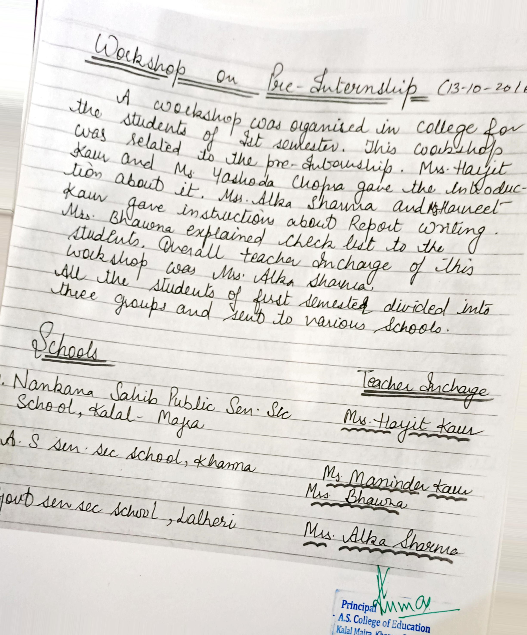

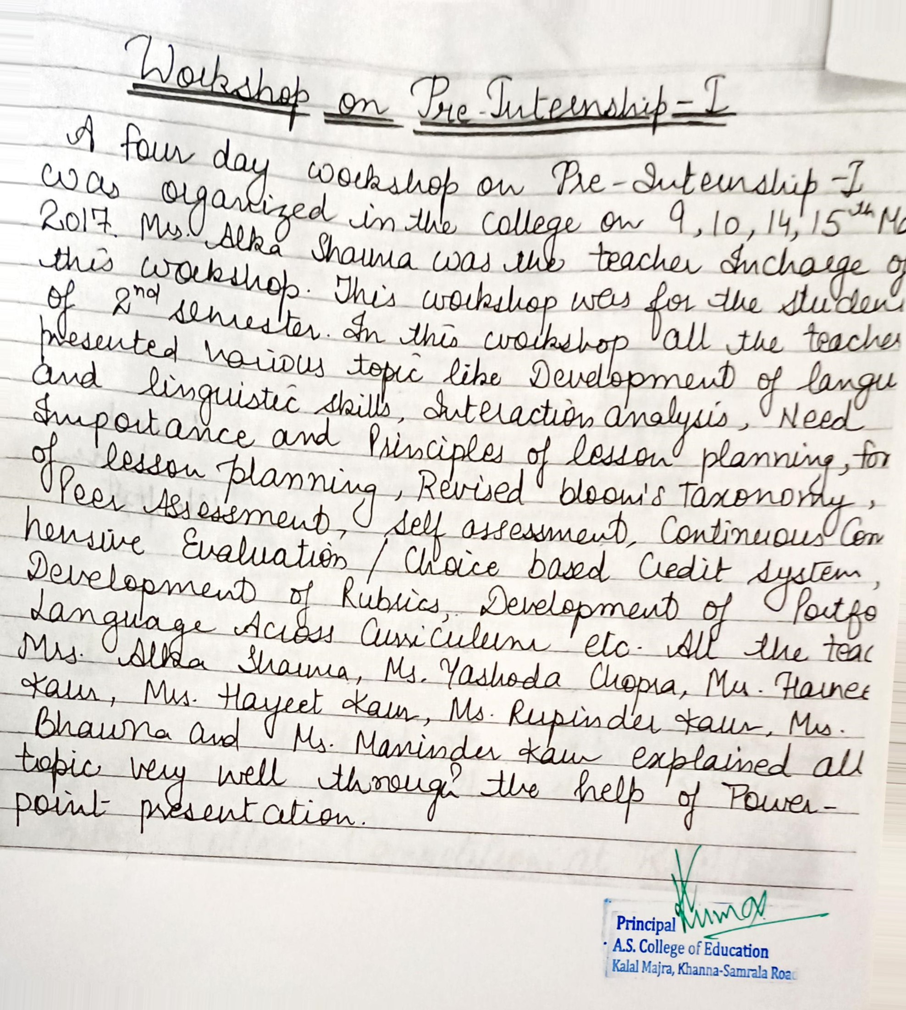
Report of the Orientation/ Induction Programme (2017-18)
4/9/2017
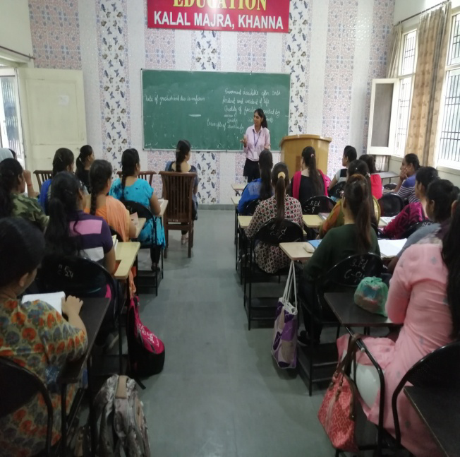
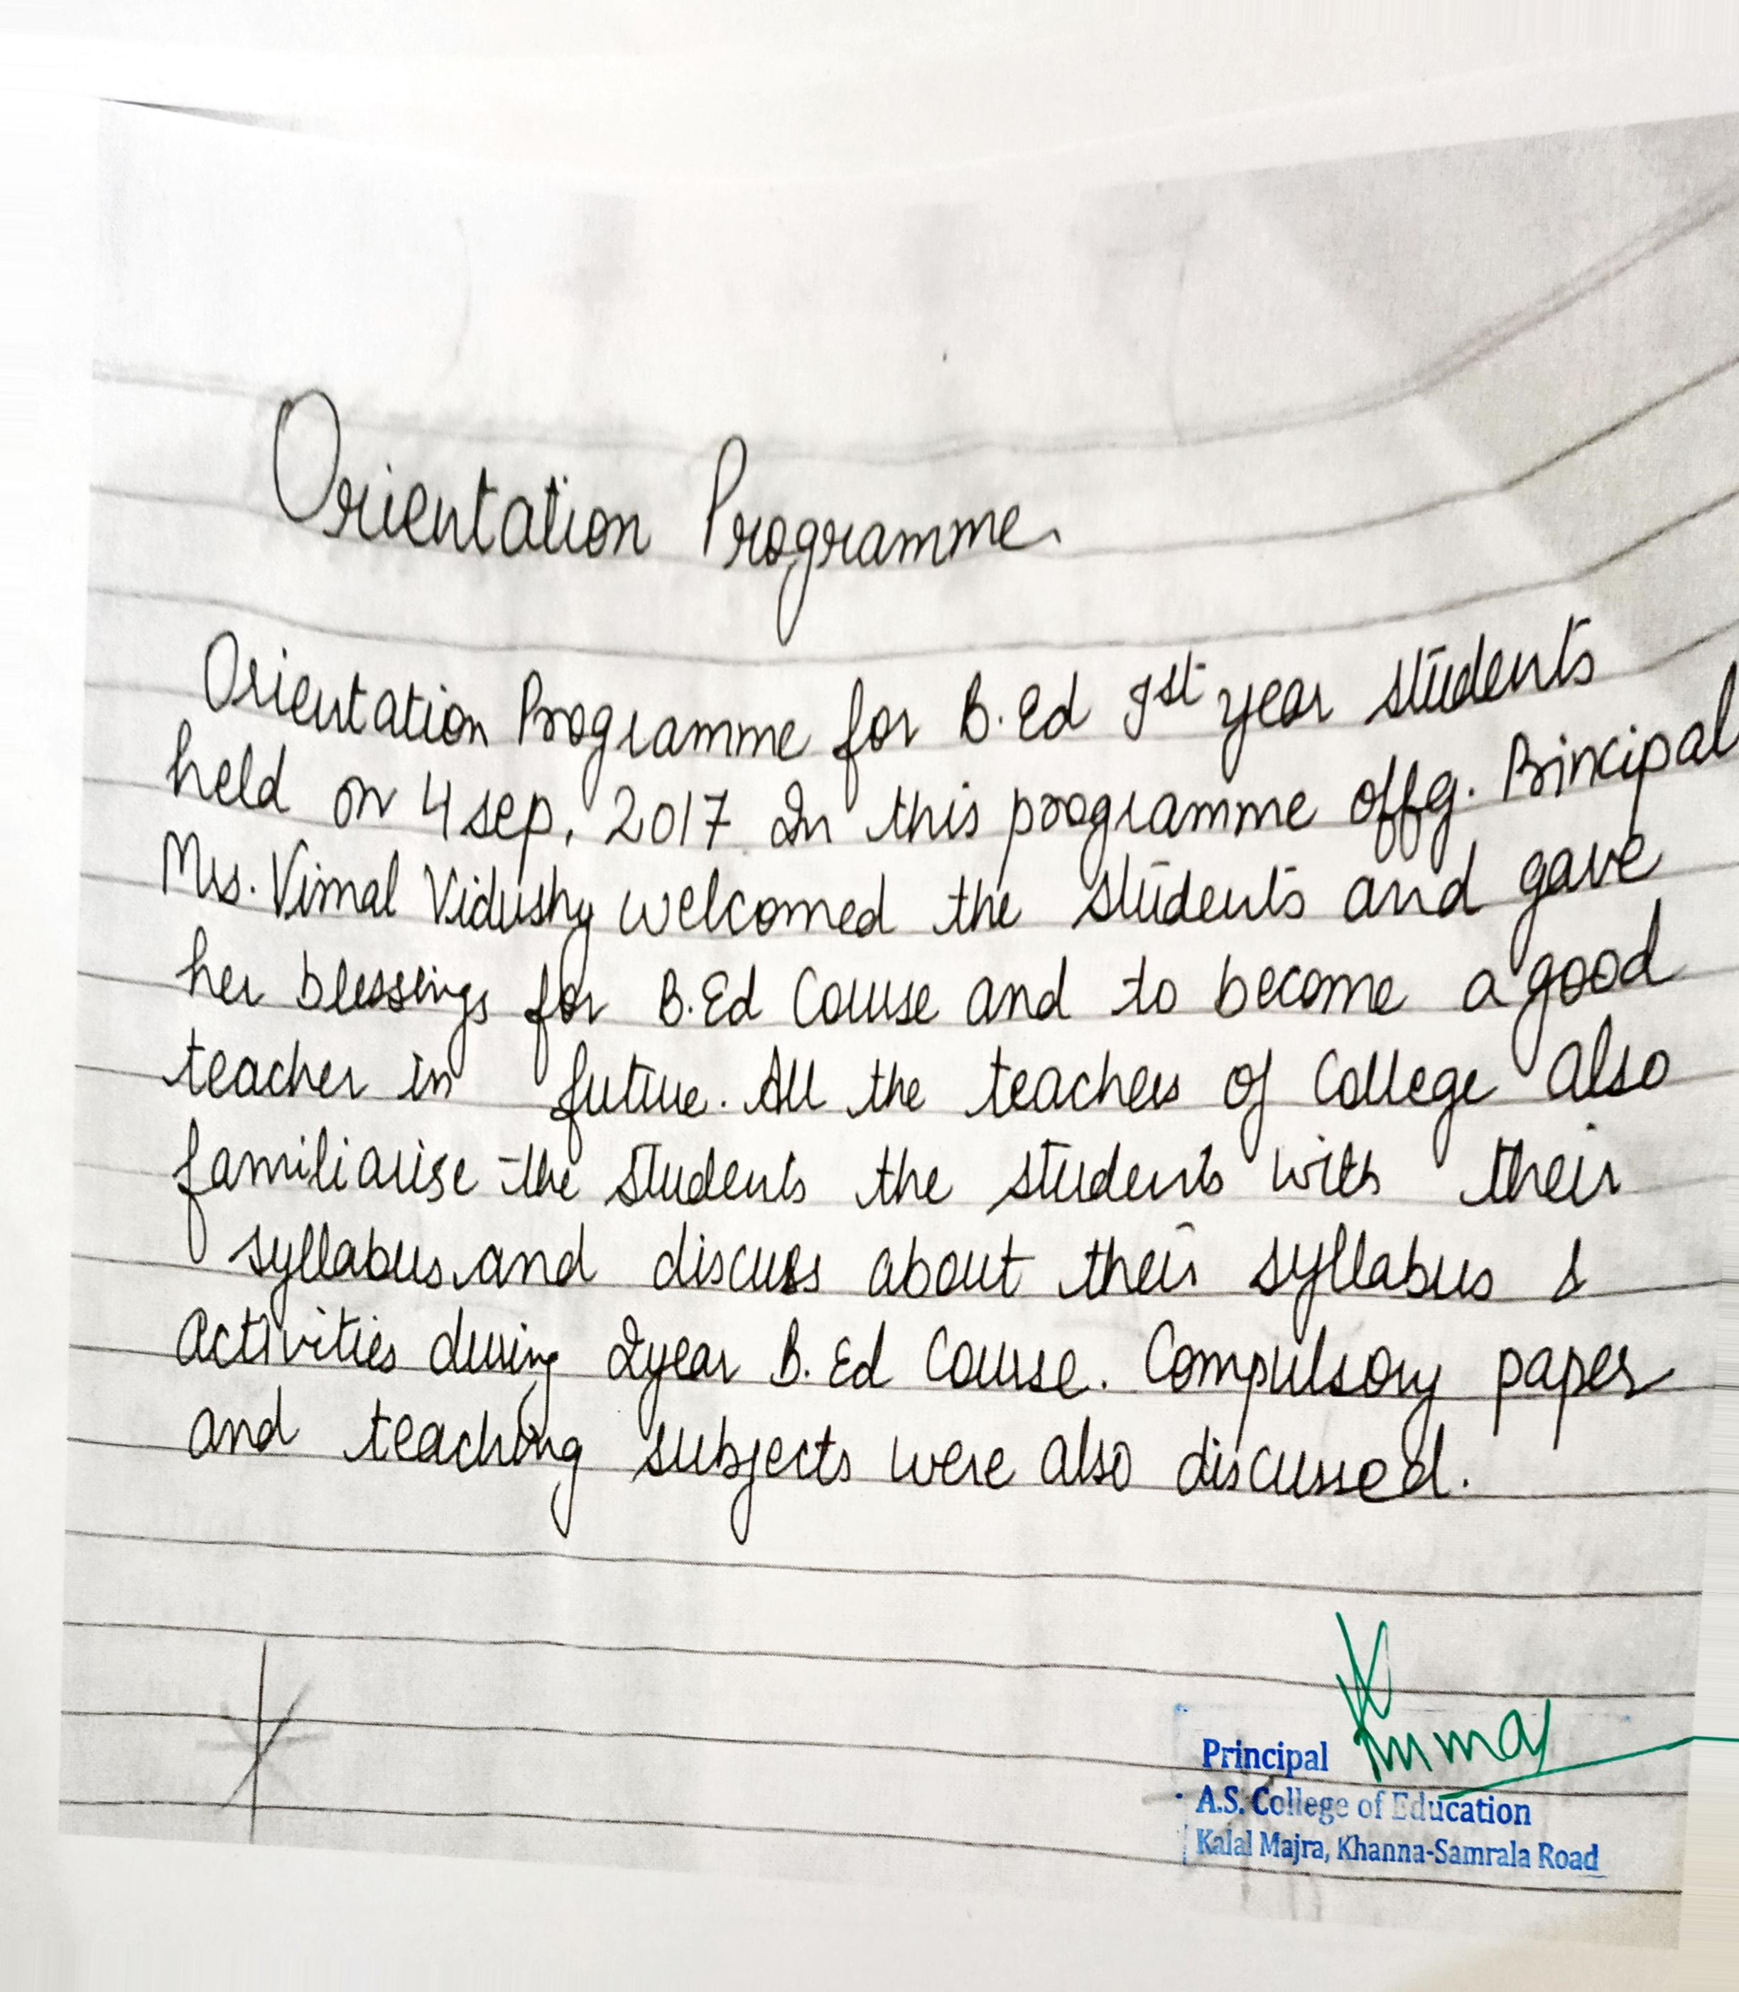

Report of workshop on School Internship Programme(2017-18)
20/7/2017-27/7/2017, 14/10/2017, 06/04/2018-10/06/2018, 11/04/2018-12/4/2018
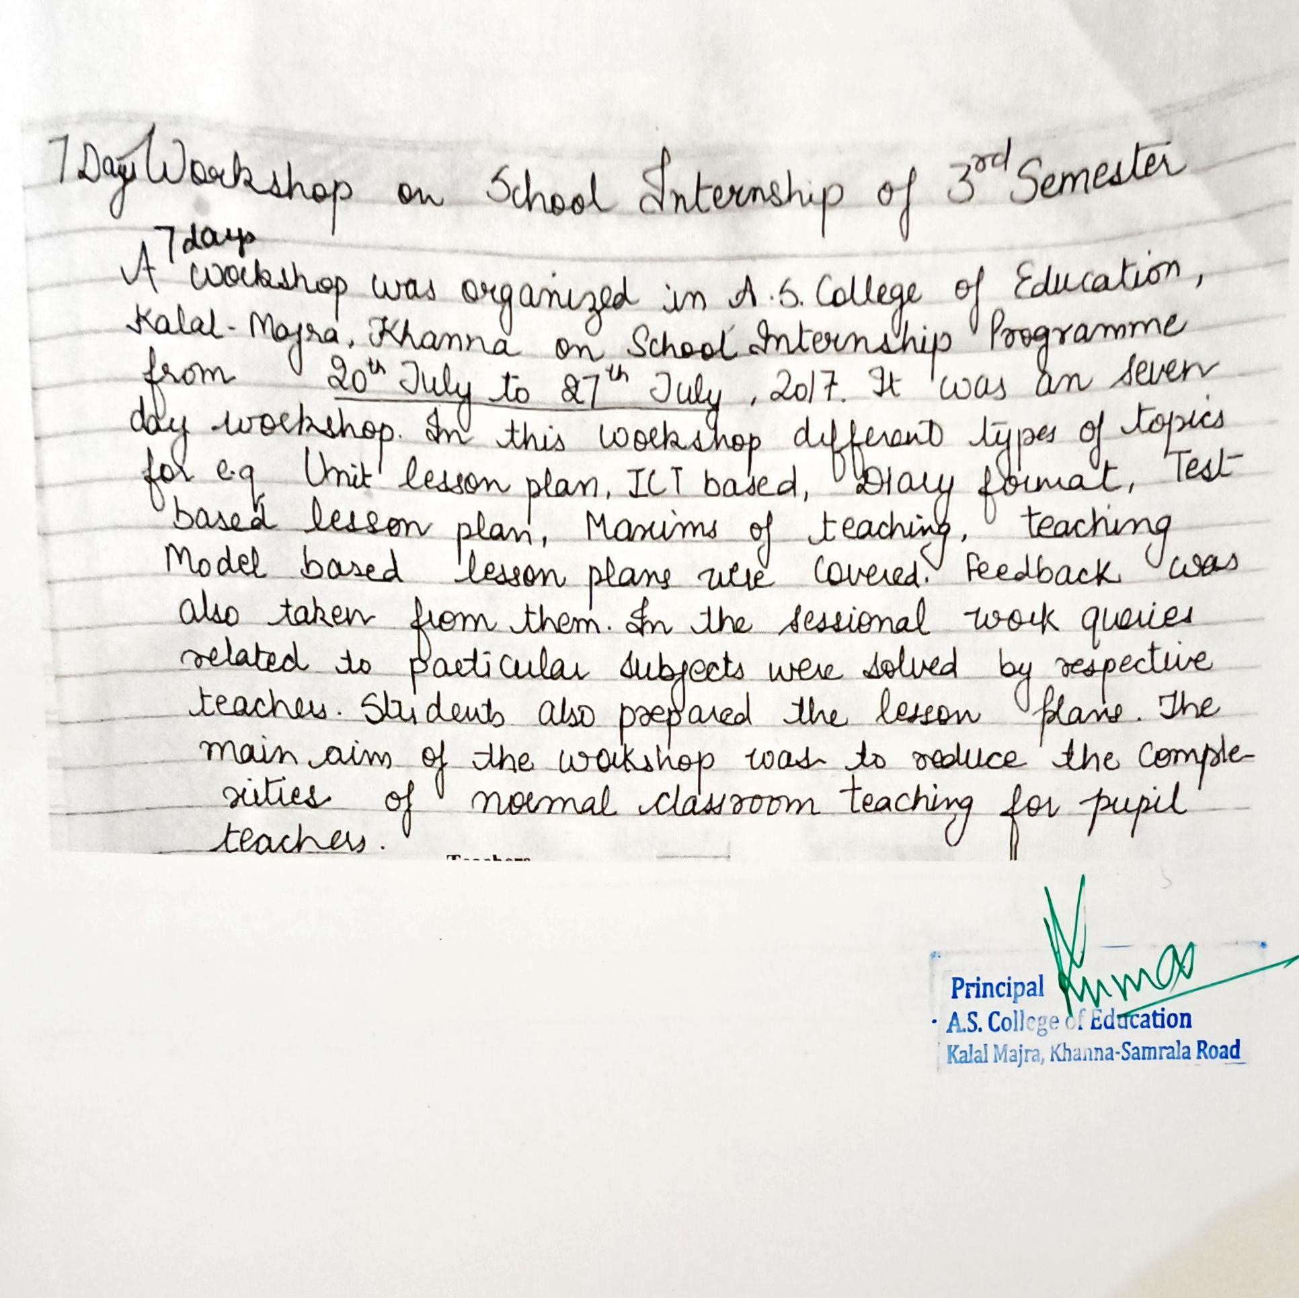
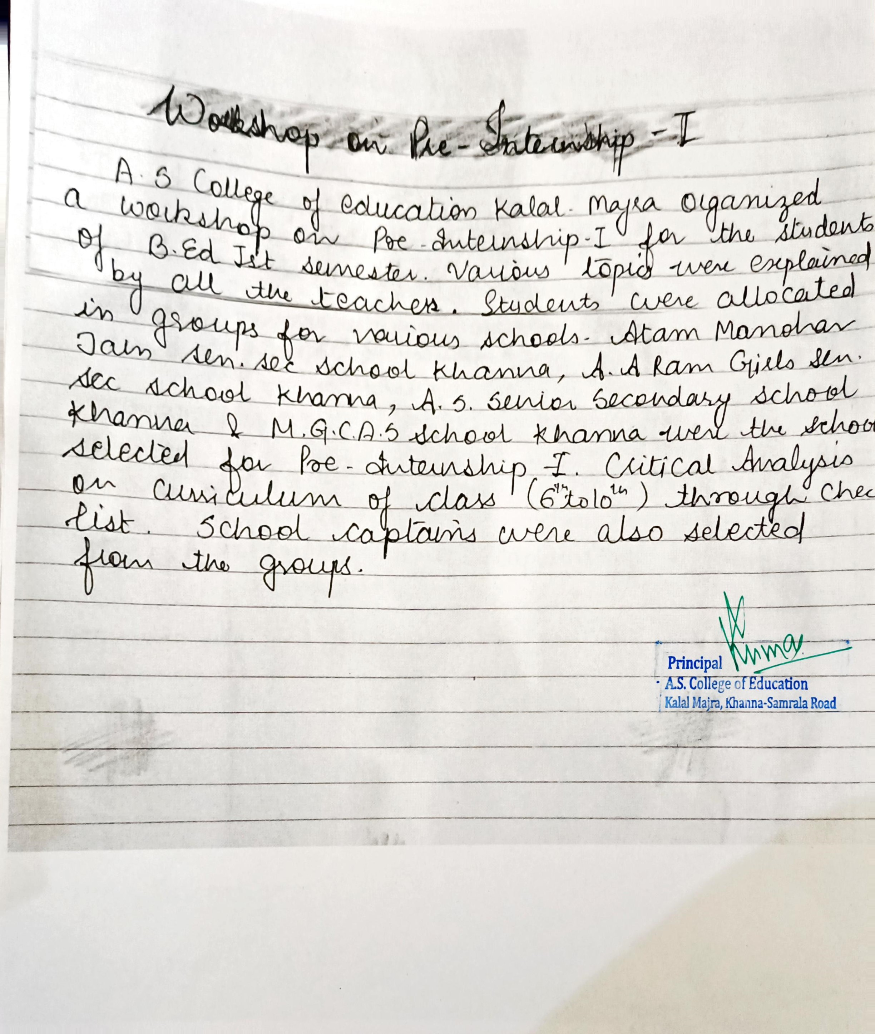

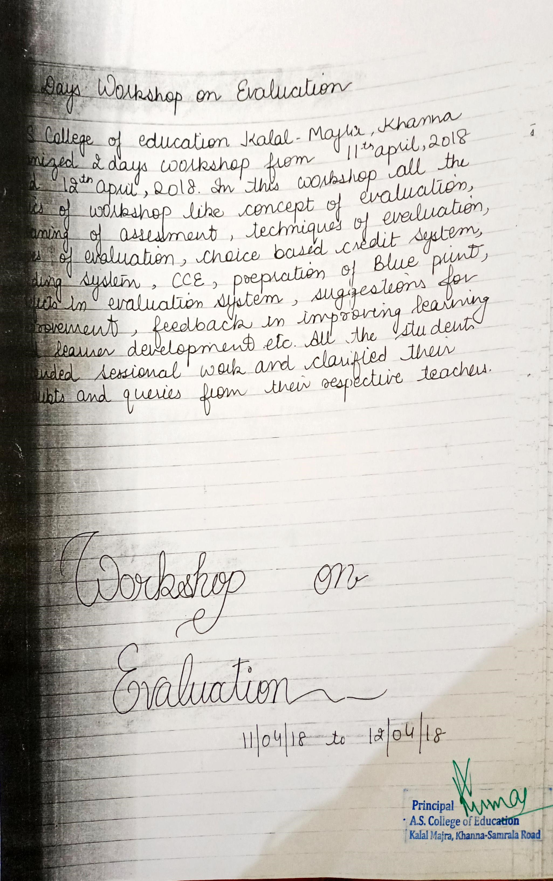
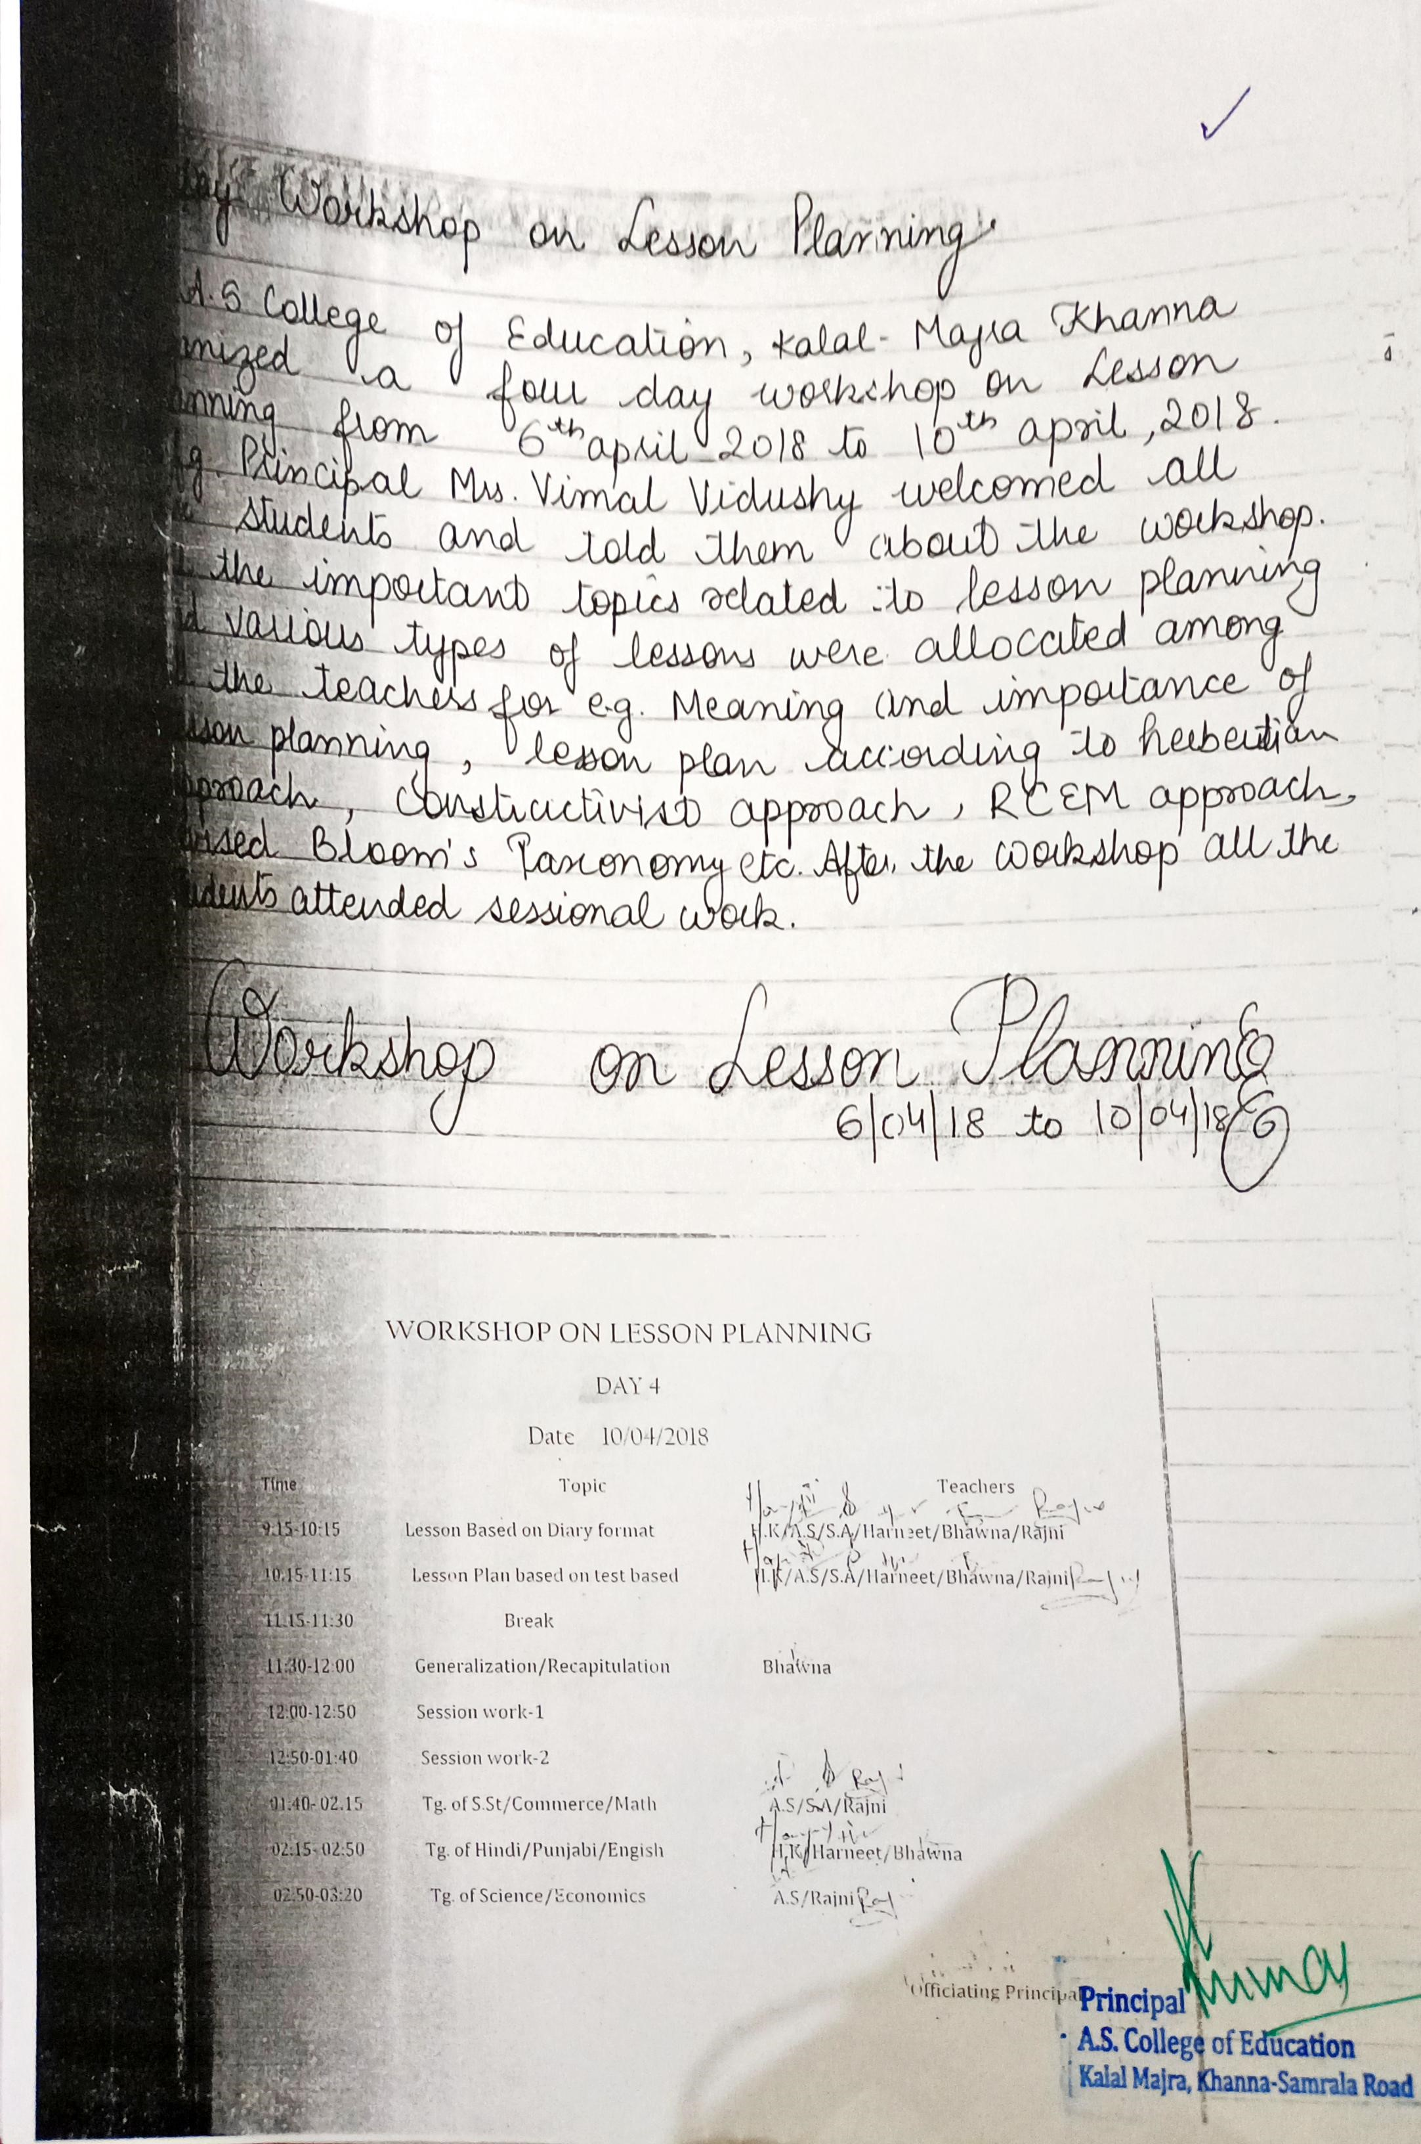

Report of the Orientation/ Induction Programme (2018-19)
10/8/18 - 11/8/18
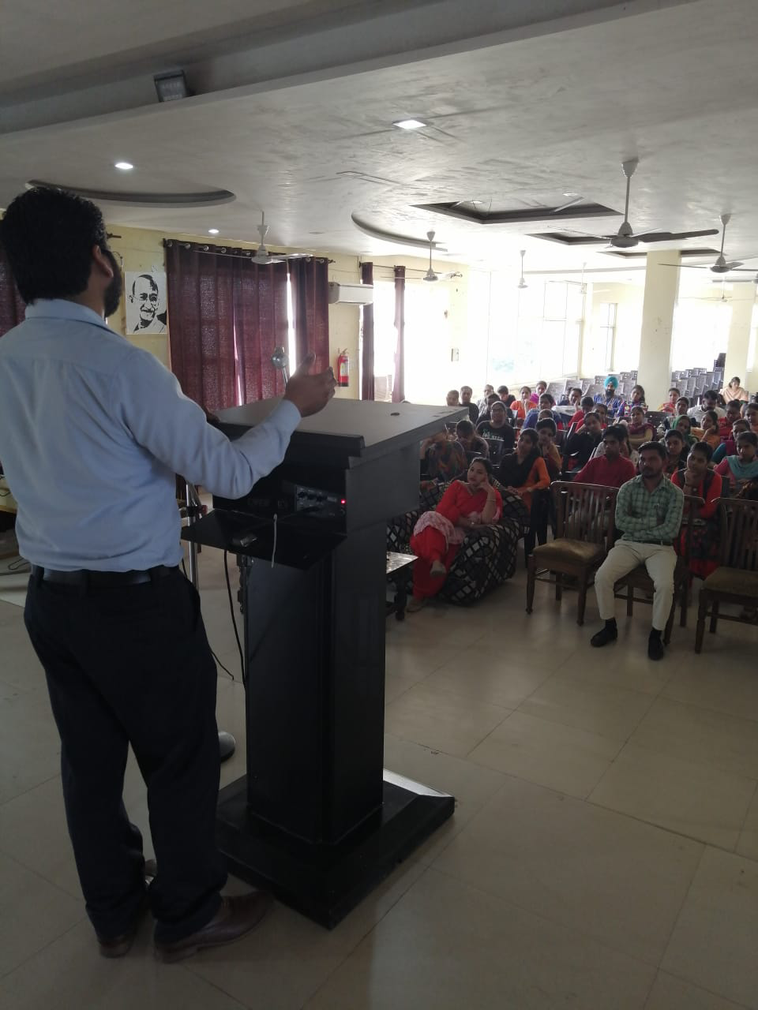
An orientation programme was organised for B.Ed. Ist year students from 10/8/18 to 11/8/18. This was intended to develop understanding of the students on the important components of course curriculum, awareness of different club and committees of the college. In which the college has familiarized the new students with the different committees and their nature of working. Different staff members of the committees aware the students towards the rule and regulations of the institution. After the orientation the convener of the committees construct the students’ committees regarding their committees.
Report of workshop on School Internship Programme(2018-19)
19/7/2018-21/7/2018, 23/7/2018-25/7/2018
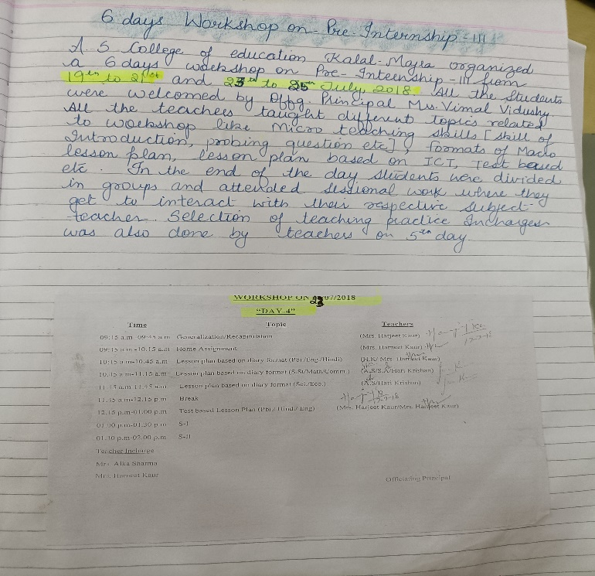
Report of the Orientation/ Induction Programme (2019-20)
26/8/2019-28/08/2019
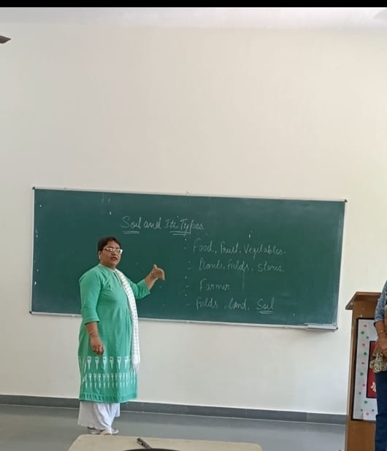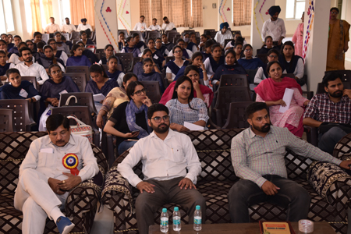

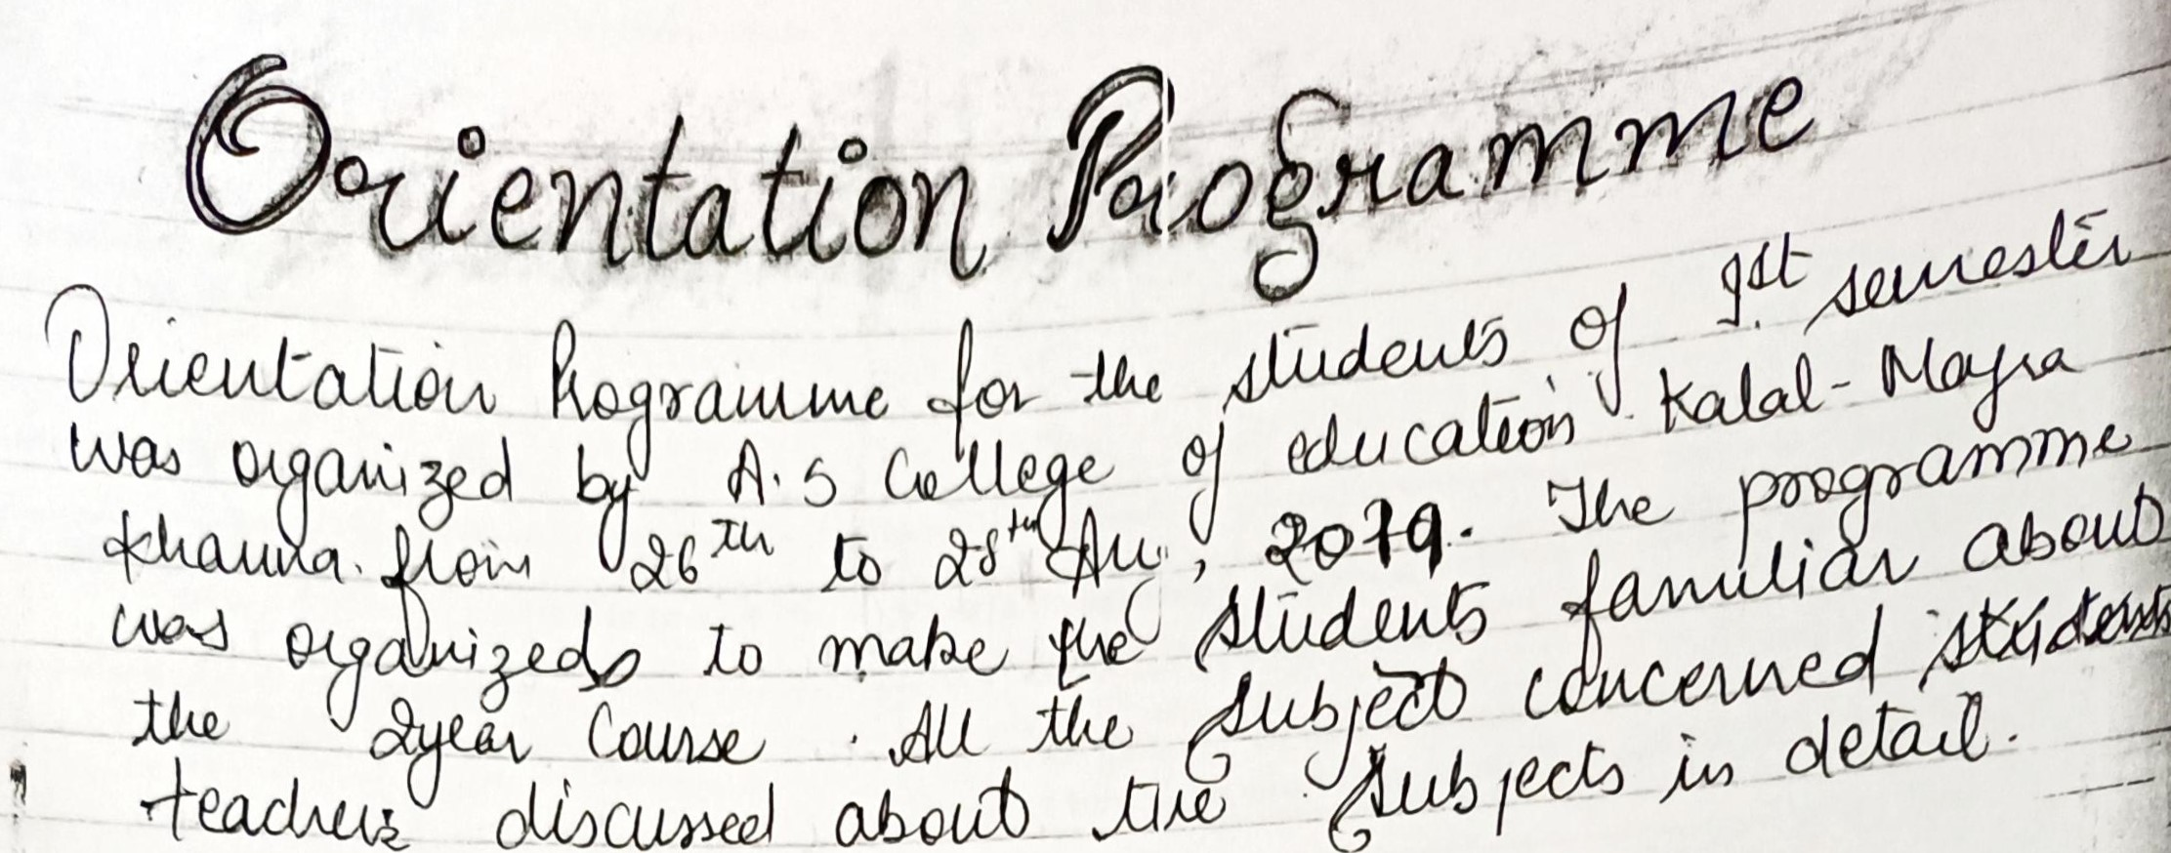

Report of workshop on School Internship Programme(2019-20)
10/7/2019-16/7/2019
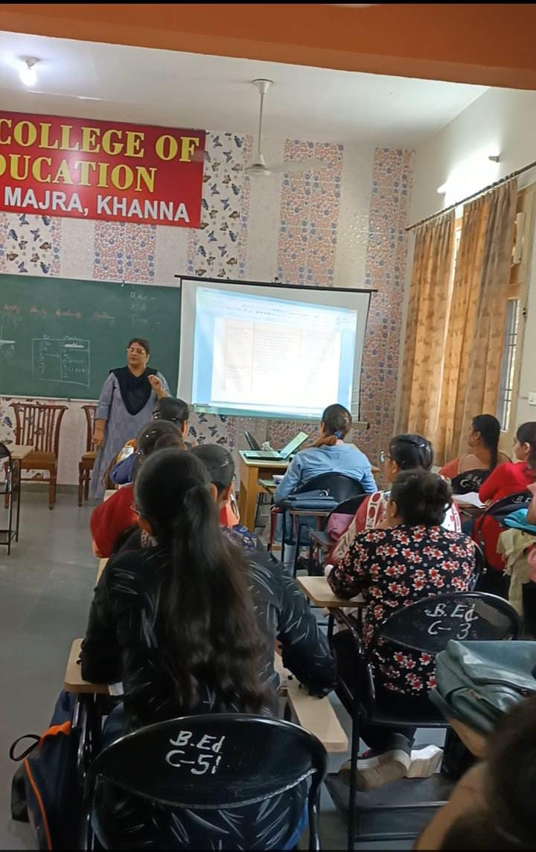
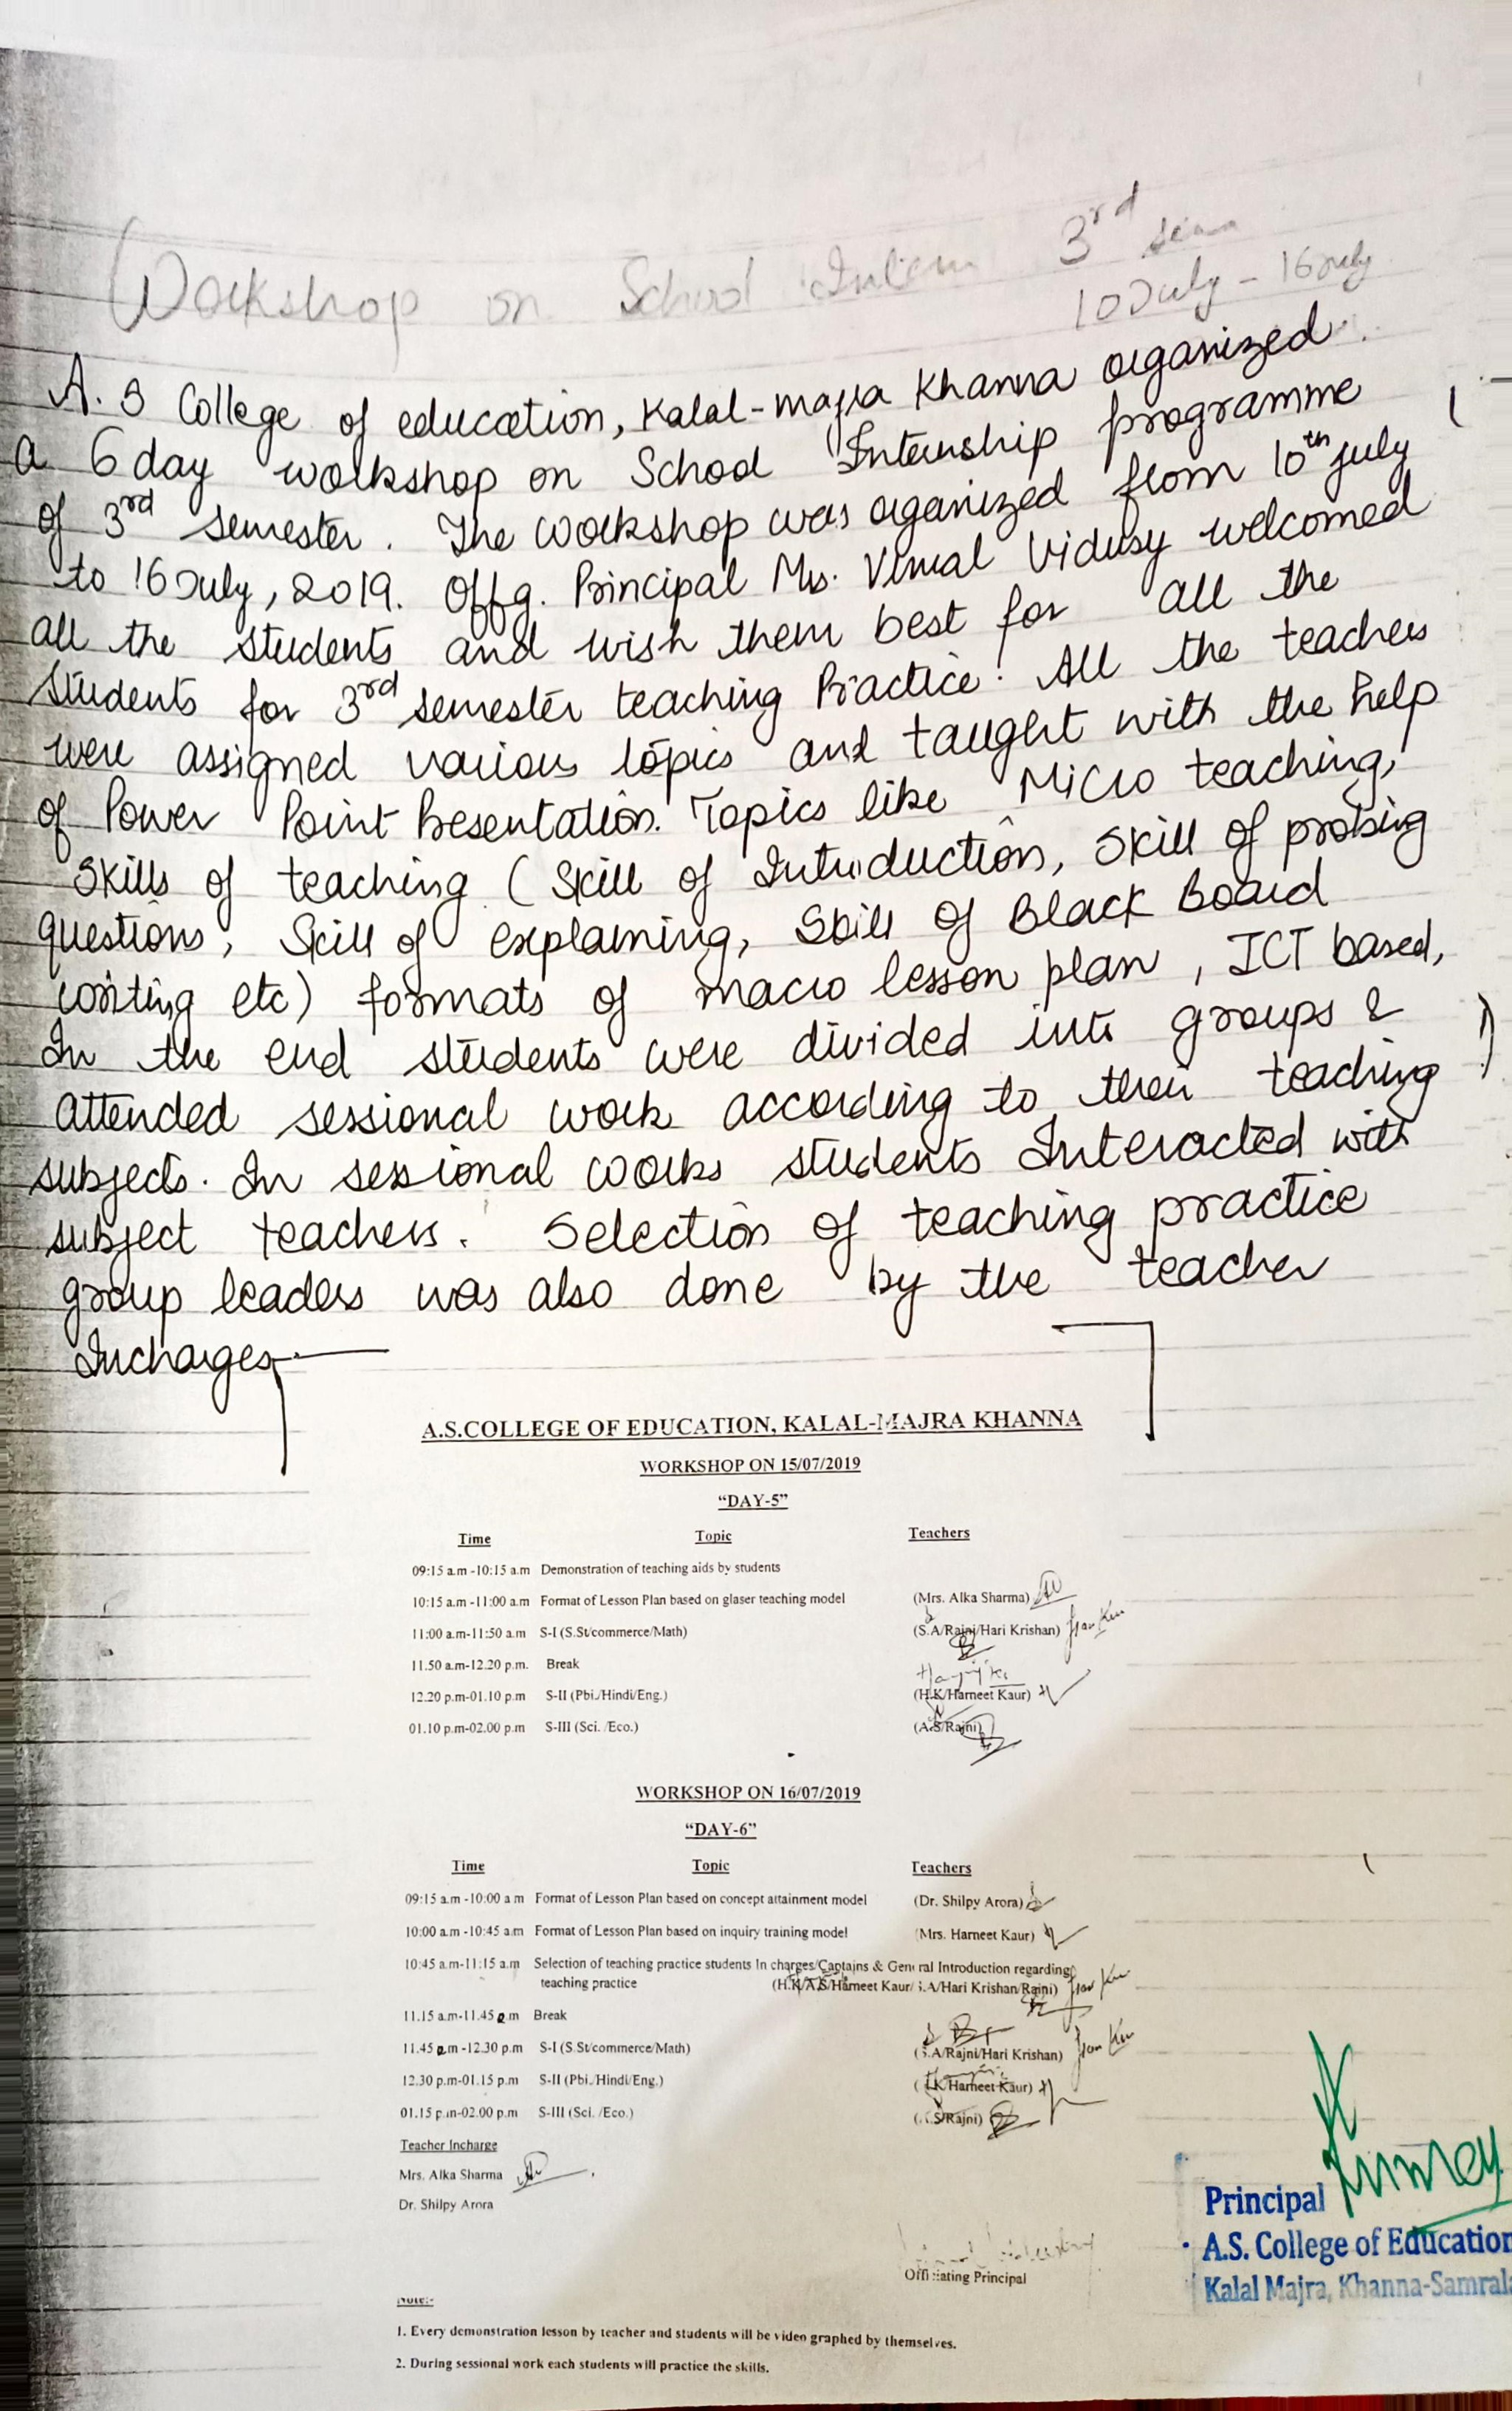

Report of the Online Orientation Programme (2020-21)
05/01/2021-7/01/2021
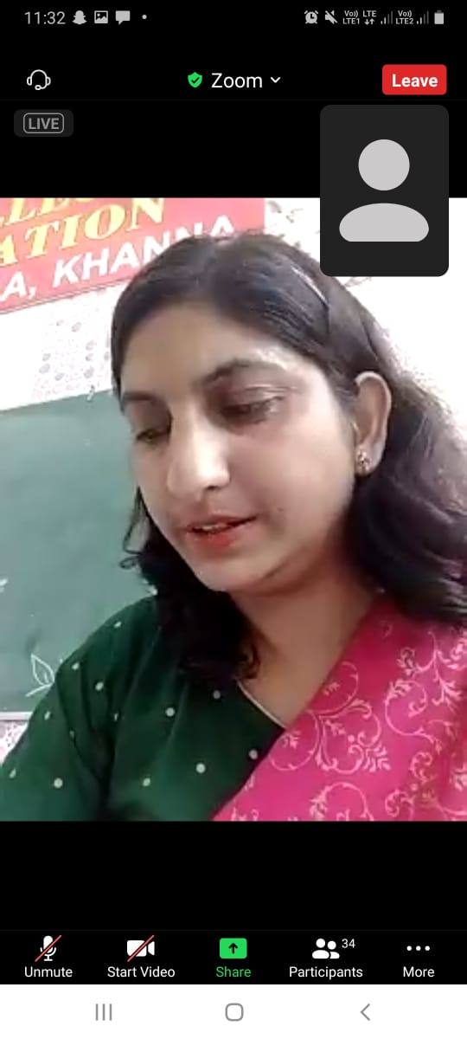
An orientation programme was organised for B.Ed. Ist year students from 5/1/21 to 7/1/21.
- The orientation provided guidelines to the students of first semester about the curriculum and marking scheme of different subjects including Teaching Practice.
- Students got familiar with institute and work culture and environment of the institution.
- The orientation provided understanding that E-learning is the wheel for new innovations.
- Students got familiar with different clubs and committees and their role for holistic development of the student.
- Introduction of various types of online platform to students.
- Introduction of students with existing staff.

Report of online workshop on School Internship Programme
27/3/2021-12/4/2021
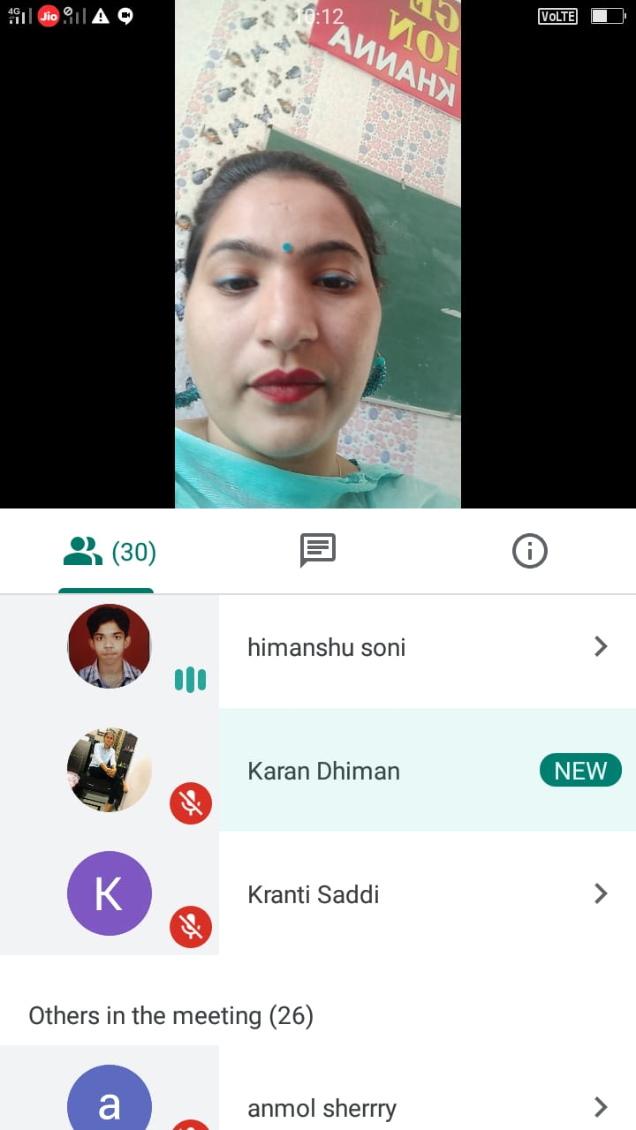

An online 11 days’ workshop on pre internship was organised from 27/3/21 to 12/4/21. In which different types of lesson planning formats, micro teaching skills, macro lessons, test-based lesson plans, teaching model-based lesson plans were explained by all subject teachers. In this workshop students were also aware about how to create google form, how to manage google classroom and various other online platforms for evaluation and teaching. The main purpose of the workshop was to reduce the complexities of the normal classroom teaching for pupil teachers.

